**HOSTEL STATISTICS**

***Report submitted to***

***Rajiv Gandhi University of Knowledge Technologies,***

***Srikakulam. for the fulfillment of mini project***

***of***

**Bachelor of Technology**

**in Computer Science and Engineering**

***by***

**G.Govardhan(S160044)**

**D.Yashwanth Raj Kumar(S160427)**

**M.J.Srinivasa Sai(S160178)**



**DEPARTMENT OF COMPUTER SCIENCE ENGINEERING**

**RAJIV GANDHI UNIVERSITY OF KNOWLEDGE TECHNOLOGIES, SRIKAKULAM MAY 2021**

© 2021, G.Govardhan, D.Yashwanth Raj Kumar, M.J.Srinivasa Sai. All rights reserved.

i

**RAJIV GANDHI UNIVERSITY OF KNOWLEDGE TECHNOLOGIES**

**DEPARTMENT OF COMPUTER SCIENCE ENGINEERING**

**(A.P. Government Act 18 of 2008)**

**RGUKT-Srikakulam, Srikakulam Dist – 532402**

**Declaration**

We certify that

1. The work contained in this report is original and has been done by us under the guidance of my supervisor(s).
2. The work has not been submitted to any other Institute for any degree or diploma.
3. We have followed the guidelines provided by the Institute in preparing the report.
4. We have conformed to the norms and guidelines given in the Ethical Code of Conduct of the Institute.
5. Whenever We have used materials (data, theoretical analysis, figures, and text) from other sources, We have given due credit to them by citing them in the text of the report and giving their details in the references. Further, We have taken permission from the copyright owners of the sources, whenever necessary.

G.Govardhan (S160044)

D.Yashwanth Raj Kumar(S160427)

M.J.Srinivasa Sai

ii

**RAJIV GANDHI UNIVERSITY OF KNOWLEDGE TECHNOLOGIES**

**DEPARTMENT OF COMPUTER SCIENCE ENGINEERING**

**(A.P. Government Act 18 of 2008)**

**RGUKT-Srikakulam, Srikakulam Dist – 532402**

**Certificate**

This is to certify that the Dissertation Report entitled, “ **Hostel Statistics** ” submitted by **Mr.G.Govardhan, Mr.D.Yashwanth Raj Kumar, Mr.M.J.Srinivasa Sai,** to Rajiv Gandhi university of Knowledge Technologies, Srikakulam, India, is a record of bonafide Project work carried out by him/her under my/our supervision and guidance and is worthy of consideration for the fulfillment of mini-project of Bachelor of Technology in computer Science and Engineering of the Institute.

________________________ _______________________

**Ms.Roopa Musidi Examiner**

Project Supervisor Project Examiner

Faculty Dept. of CSE Faculty Dept. of CSE

**RGUKT IIIT Srikakulam RGUKT IIIT Srikakulam**

Date:

iii

**ACKNOWLEDGEMENT**

We would like to express our profound gratitude and deep regards to our guide ***Ms. Roopa Musidi*** for his exemplary guidance, monitoring and constant encouragement to usthroughout this semester. We shall always cherish the time spent with him during the course of this work due to the invaluable knowledge gained in the field of Deep Learning.

We are extremely grateful for the confidence bestowed in us and entrusting our project entitled **“Hostel Statistics”.**

We express gratitude to Mr.Ch.Satish Kumar (HOD of CSE) and other faculty members for being a source of inspiration and constant encouragement which helped us in completing the project successfully.

Finally, yet importantly, we would like to express our heartfelt thanks to our beloved God and parents for their blessings, our friends for their help and wishes for the successful completion of this project.

G.Govardhan (S160044)

D.Yashwanth Raj Kumar (S160427)

M.J.Srinivasa Sai (S160178)

iv

**ABSTRACT**

The project deals with the students present, on the campus and off the campus where the

concerned caretaker updates the details of the students.Currently, the details of the students who

are present on the and off the campus, in the sick room and the number of the students who are

in leave are sent to the particular chief-warden, is done through messaging either in whatsapp or

messaging. When transferring the list of the students in the whatsapp or messages is not much

secure.If any kind of problem occurs like data crash or if the mobile gets broken it is not easy to

retrieve the data from the phone if it is not solved. It’s like temporary storage sometimes. It can

be accessed by only the person it has and if any of the administration or chief-warden is needed,

The particular person who has the data has to transfer to the other and it is a time taking process.

In Order to reduction of transfer of these time taking things we provide a website where

any of the authorized people can access the data from the database. The input is the calendar

which is given by the person who needed the details of the students on a particular date.

***Keywords:*** storage, authorized, administration, transfer.

v

**CONTENTS**

|  |  |  |
| --- | --- | --- |
| Title Page | i |  |
| Declaration | ii |  |
| Certificate by Supervisor | iii |  |
| Acknowledgement | iv |  |
| Abstract | v |  |
| Contents | vi |  |
| Chapter 1 Introduction  1.1 Problem Statement  1.2 Motivation of the Project  1.3 Limitations of the Project  1.4 Existing System  1.5 Proposed System | 1  1  1  1  2  2 |  |
| Chapter 2 Literature Review  2.2 Technology Overview  2.2.1 Sublime Text | 3  3 |  |
| Chapter 3 Requirement Specification  3.1 Functional Requirements  3.2 Non-Functional Requirements  3.3 System Requirements    3.3.1 Hardware Requirements  3.3.2 Software Requirements | 5  5  6  7  7  7 | vi |
| Chapter 4 Methodology | 8 |  |
| Chapter 5 System Design  5.1 Introduction  5.2 Use Case Diagram & Data Flow Diagram | 9  9  10 |  |
| Chapter 6 Results | 13 |  |
| Chapter 7 Testing and Validation  8.1 Introduction  8.2 Types of Testing  8.2.1 Unit Testing  8.2.2 Integration Testing  8.3 Validation | 18  18  19  19  19 19 |  |
| Chapter 8 Conclusion | 20 |  |
| Appendix | 21 |  |

vii

**1. INTRODUCTION**

**1.1 Problem Statement**

Hostel Management System is developed for easy report of activities in hostels. This web application will help users in case of reporting and searching information about students and rooms. This application is a great relief for teachers and chief-wardens. It helps in providing the faster access of data and allowing modification and deletion of data in a systematic and reliable manner.

**1.2 Motivation of the Project**

We want to use the html, css ,js, and php for a better user interface, validations, and to store the details of the students into the database. Even though there are existing systems for the storage of data, we would like to create them on our own. In our project, we would like to explore our own creativity and for a practical approach.

**1.3 Limitations of the Project**

The input details are only accepted with the positive numbers but if any of the negative numbers are entered, are also stored in the database but when the data is retrieved it would lead to misconception. And, one must enter the details correctly in order to maintain the correct information.

**1.4 Existing System**

There is already a system which is from many years ago. The existing system is manually maintained which is on paperwork. These details are entered and retrieved manually which is a time consuming task. However, they neglect the accuracy of the data and the consumption of time, and data backup when necessary.

**1.5 Proposed System**

The proposed system is a computerized version of the existing system. It provides easy and quicker access to the data and authorization is required and is secured. One who is authorized to enter the details will also be able to edit the details of the particular date, and whenever necessary one can able to download the details that are retrieved.

**2. LITERATURE REVIEW**

**2.1 Technology Overview**

The software that is being used for our project implementation is Sublime Text of version 4 which is the latest version and is used for writing several scripting languages, text documents, and programming languages. Scripting languages like HTML, JS, CSS can be written easily.

**2.1.1 Sublime Text**

Sublime Text is a cross-platform source code editor with an Application Programming Interface (API). It supports many programming languages, markup languages, and functions can be added using plugins.It has numerous extensions for syntax highlighting, source code finding and analyzing code metrics makes the new programmers accessible.

It has many features like autocompletion, syntax highlighting, customizability, lightweight which loads instantaneously. In addition to that it is fast enough to run and stable.In addition to that it has simultaneous editing which helps in reformatting several lines of code at the same time and it has a feature called minimap which helps in showing you the current position when moving the scroll bar in a large file.

The Markup Language that we used here is Hyper Text Markup Language (HTML), Cascading Style Sheet (CSS) which helps in designing of the web page and adding styles to the webpages in our web application. These are used to design the User Interface with applying styles to it. The version used is HTML5 which also supports the validations.

The Scripting Language used in is JavaScript which performs the validations in the forms in the web pages. It shows whether the given data matches using the regular expressions that are provided as the constraints.

The Server Side Language used in is HyperText Preprocessor (PHP) which is used to store the data on the server in the form of tables and is used to retrieve the data when needed in the pages.

We used a bootstrap framework which is a combination of HTML, JS, CSS, PHP, DJANGO etc languages. These are helpful in boosting the performance and efficiency of the web application.

**3. REQUIREMENT SPECIFICATION**

Requirements-Determination is the process by which an analyst gains the knowledge of the organization and applies it in selecting the right technology for a particular application. A Software Requirements Specification (SRS) is a complete description of the behaviour of the system to be developed. It includes a set of use cases that describe all the interactions the users will have with the software. Use cases are also known as functional requirements. In addition to use cases, the SRS also contains non-functional requirements. Non-functional requirements are requirements which impose constraints on the design or implementation (such as quality standards).

**3.1 Functional Requirements**

In software engineering, a functional requirement defines a function of a software system or its component. A function is described as a set of inputs, the behaviour, and outputs. Functional requirements may be calculations, technical details, data manipulation and processing and other specific functionality that define what a system is supposed to accomplish. Behavioural requirements describing all the cases where the system uses the functional requirements are captured in use cases. Functional requirements are supported by non-functional requirements (also known as quality requirements), which impose constraints on the design or implementation (such as performance requirements, security, or reliability).

**Functional Requirements for Present Project**

1. Input: Details of the students on a particular date.
2. Output: When a date is given the data on that particular date is given as output.
3. Process: The details entered by the caretaker are stored in the database and when either the warden or chief-warden enter the particular date it displays the information that is stored on that particular date.

**3.2 Non-Functional Requirements**

In systems engineering and requirements engineering, a non-functional requirement is a requirement that specifies criteria that can be used to judge the operation of a system, rather than specific behaviours. This should be contrasted with functional requirements that define specific behaviour or functions In general; functional requirements define what a system is supposed to do whereas non-functional requirements define how a system is supposed to be. Non-functional requirements are often called qualities of a system. Other terms for non-functional requirements are "constraints", "quality attributes", "quality goals" and "quality of service requirements," and "non-behavioural requirements." Qualities, that is, non-functional requirements, can be divided into two main categories one is Execution qualities, such as security and usability, which are observable at run time and Evolution qualities, such as testability, maintainability, extensibility and scalability, which are embodied in the static structure of the software system.

**Non-Functional Requirements for Present Project**

Any user can interact with the application easily. The application shows the data faster as there is only searching required in not more than two tables.

**3.3 System Requirements**

To be used efficiently, all computer software needs certain hardware components or other software resources to be present on a computer. These prerequisites are known as (computer) system requirements and are often used as a guideline as opposed to an absolute rule. Industry analysts suggest that this trend plays16 a bigger part in driving upgrades to existing computer systems than technological advancements.

**3.3.1 Hardware Requirements**

The most common set of requirements defined by any operating system or software application is the physical computer resources, also known as hardware, a hardware requirements list is often accompanied by a hardware compatibility list (HCL), especially in case of operating systems. An HCL lists tested, compatible, and sometimes incompatible hardware devices for a particular operating system or application. The following subsections discuss the various aspects of hardware requirements.

**Hardware Requirements for Present Project**

1. Processor: Intel Core I5/ I7
2. RAM: 4GB
3. Storage: 20GB
4. Monitor with 1024*720 resolution

**3.3.2 Software Requirements**

Software Requirements deal with defining software resource requirements and prerequisites that need to be installed on a computer to provide optimal functioning of an application. These requirements or pre-requisites are generally not included in the software installation package and need to be installed separately before the software is installed.

**Software Requirements for Present Project**

1. Operating System: Windows 10
2. Developing Platform: Any text editor such as notepad, sublime text
3. Languages: HTML, JS, CSS, PHP
4. Browsers: Google Chrome

**4. METHODOLOGY**

The methodology is the process of executing an application and the steps involved in it.

Here, in our application the process or the steps that are done as follows. They are

Initially we move to the login interface where we can login based on the designation of the faculty such as a caretaker when logged in move to the page where on can enter the details of the students and when it comes to the wardens and chief-wardens they are moved into the page where they can get details on a particular date.

When an user is registered one can login to the application orelse an individual should register on the base of their designation on clicking the create an account which is on the login page which is used to register.

When registered the details of the user are stored into the database using sql queries. When an attempt is made to login, if the user is registered then one can move to the respective pages based on their designation or if the user is not registered then directed to the registration page using ‘create an account’.

**5. SYSTEM DESIGN**

**5.1 Introduction**

Grady Booch, James Raumbaugh and Ivar Jacobson have collaborated to combine the best features of their individual object oriented analysis and design methods into a unified method the unified modeling language, the version 1.0 for the Unified Modeling was released in January 1997 the main parts of UML are based on the Booch, OMT and OOSE methods. The goals of UML are:

1. To model systems using object-oriented concepts
2. To establish an explicit coupling between conceptual as well as executable
3. To address the issues of scale inherent in complex, mission critical system
4. To create a modeling language usable by both humans and machines

**Basic Building Blocks of UML**

The basic building blocks in UML are things and relationships; these are combined in different ways following different rules to create different types of diagrams. In UML there are nine types of diagrams, below is a list and brief description of them. The more in depth descriptions in the document, will focus on the first five diagrams in the list, which can be seen as the most general, sometimes also referred to as the UML core diagrams.

**Use case Diagram:** shows a set of use cases, and how actors can use them.

**Class Diagram:** describes the structure of the system, divided in classes with different connections and relationships

**Sequence Diagram:** shows the interaction between a set of objects, through the messages that may be dispatched between them.

**State chart Diagram:** state machines, consisting of states, transitions, events and activities.

**Activity Diagram:** shows the flow through a program from a defined start point to an end point.

**Object Diagram:** A set of objects and their relationships, this is a snapshot of instances of the things found in the class objects.

**Collaboration Diagram:** Collaboration diagram emphasizes structural ordering of objects that send and receive messages.

**Component Diagram:** shows organizations and dependencies among a set of components. These diagrams address the static implementation view of the system.

**Deployment Diagram:** show the configuration of run-time processing nodes and components that live on them.

**5.2 UseCase Diagram**

Use case diagram is the primary form of system/software requirements for a new software program underdeveloped. Use cases specify the expected behavior (what), and not the exact method of making it happen (how). Use cases once specified can be denoted both textual and visual representation (i.e. use case diagram). A key concept of use case modeling is that it helps us design a system from the end user's perspective. It is an effective technique for communicating system behavior in the user's terms by specifying all externally visible system behavior.

Use case diagrams are typically developed in the early stage of development and people often apply use case modeling for the following purposes:

* Specify the context of a system
* Capture the requirements of a system
* Validate a systems architecture
* Drive implementation and generate test cases
* Developed by analysts together with domain experts

**UseCase Diagram**

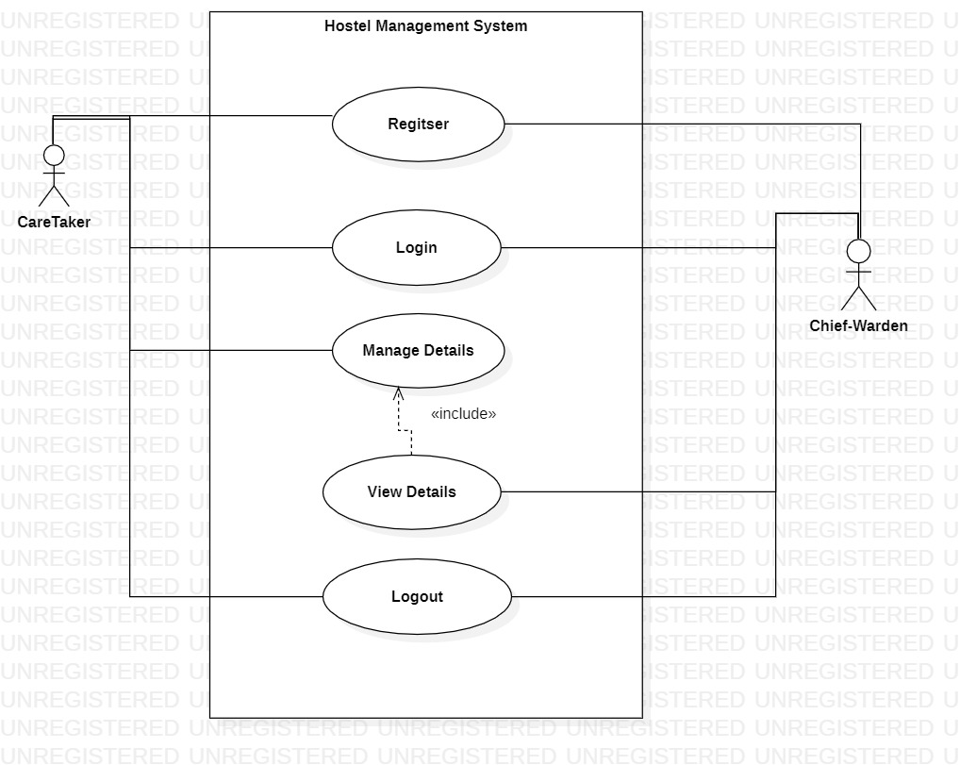

Fig 5.1: Use Case Diagram

**Data Flow Diagram**

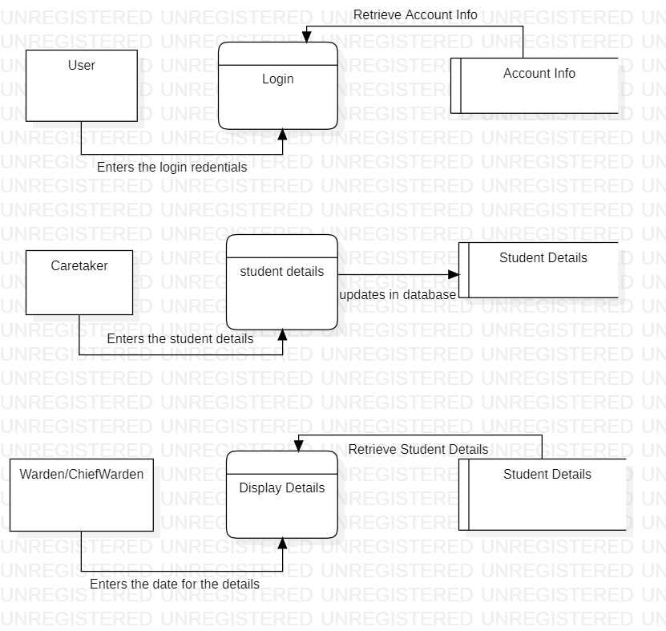

Fig 5.2- Data Flow Diagram

**6 . RESULTS**

The data is entered into the database and can be retrieved from the database based on the date given by the respective warden or chief-warden which is displayed in the form of a table.

**Images**

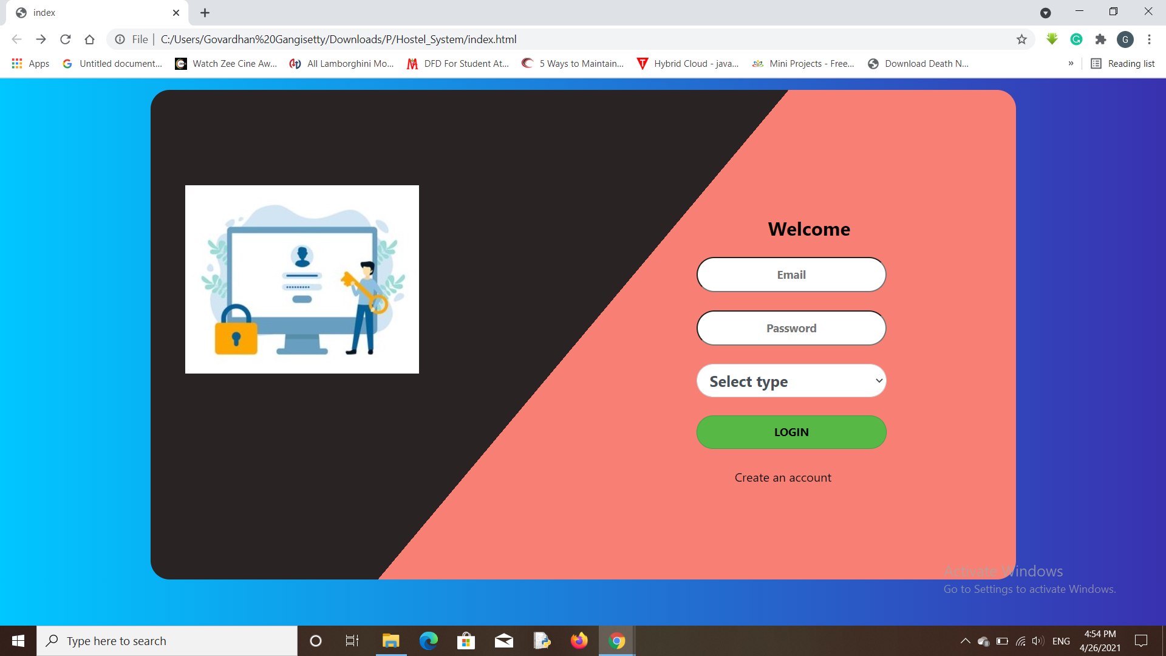

Fig 7.1 - Login Page

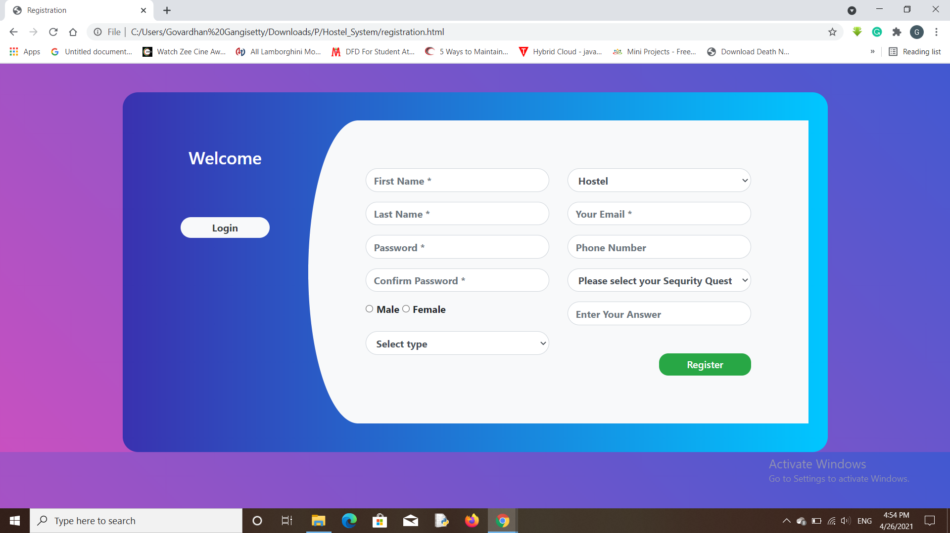Fig 7.2 - Registration Page

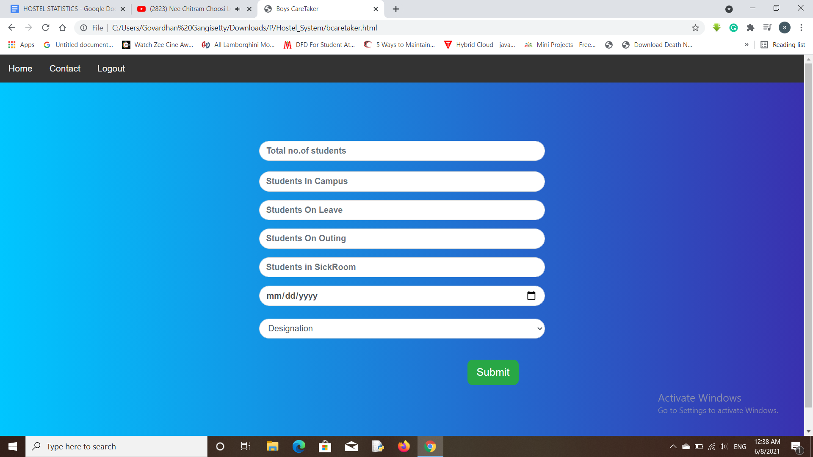

Fig 7.3- Caretaker page

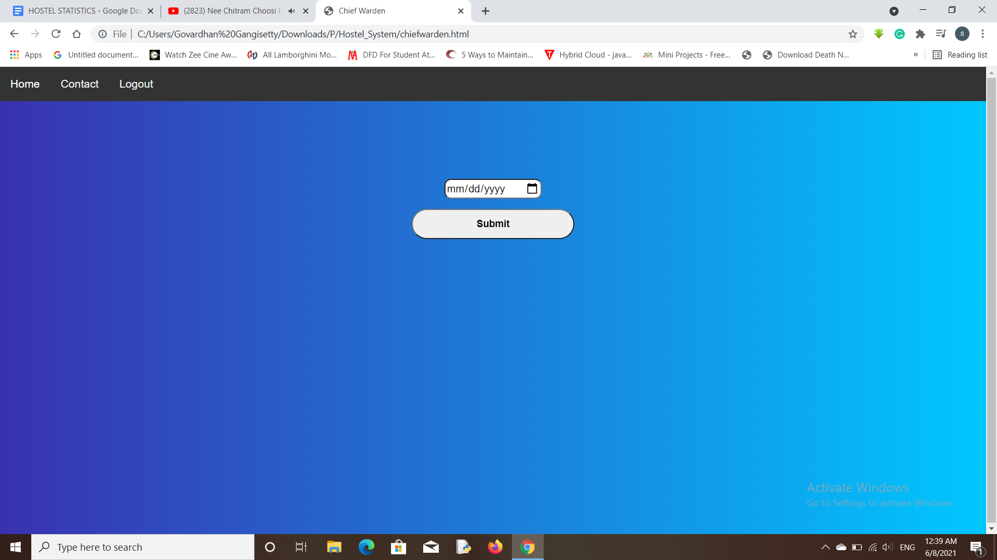

Fig 7.4- Warden & Chief-Warden Page

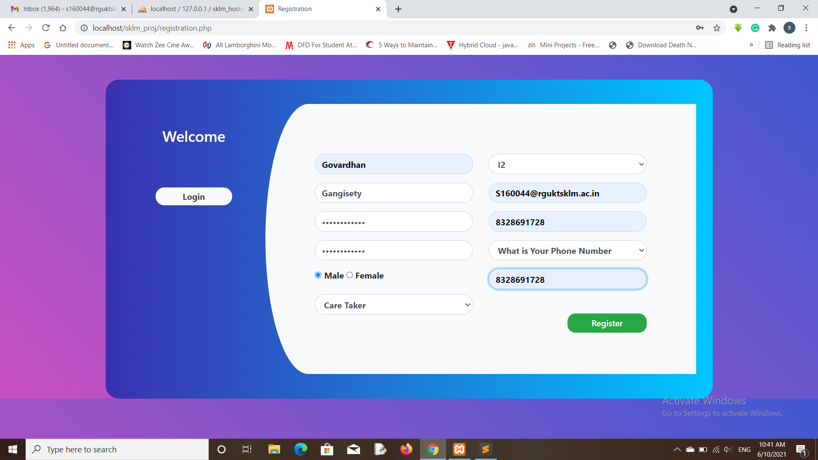

Fig- 7.5 Registration details

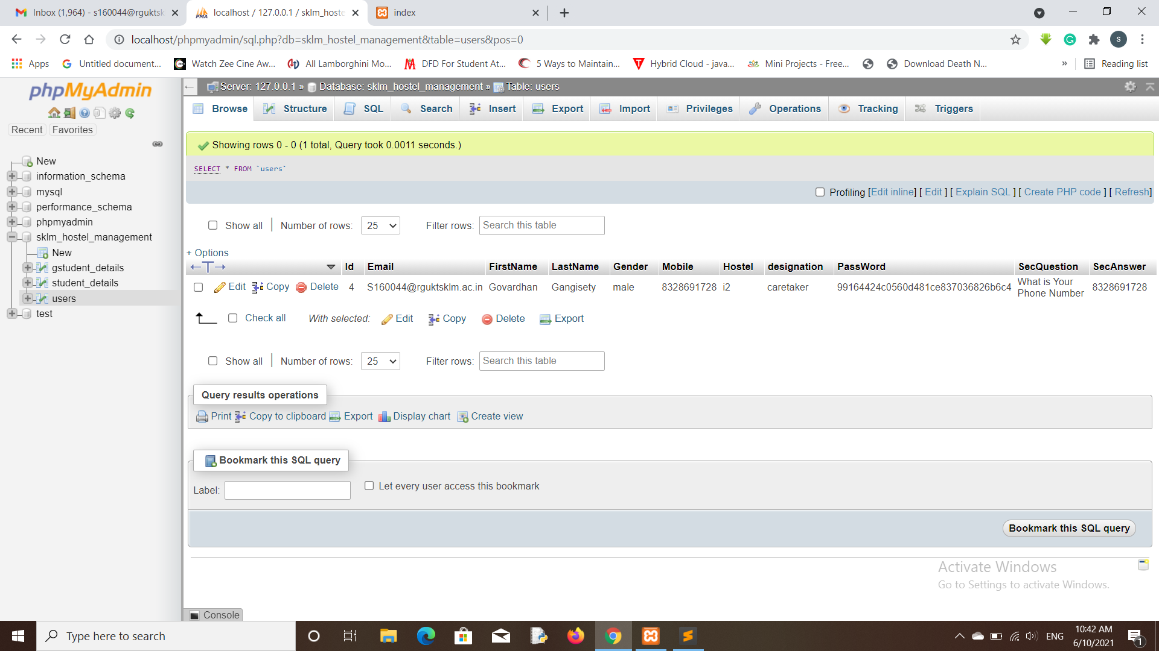

Fig- 7.6 Data Stored in database table

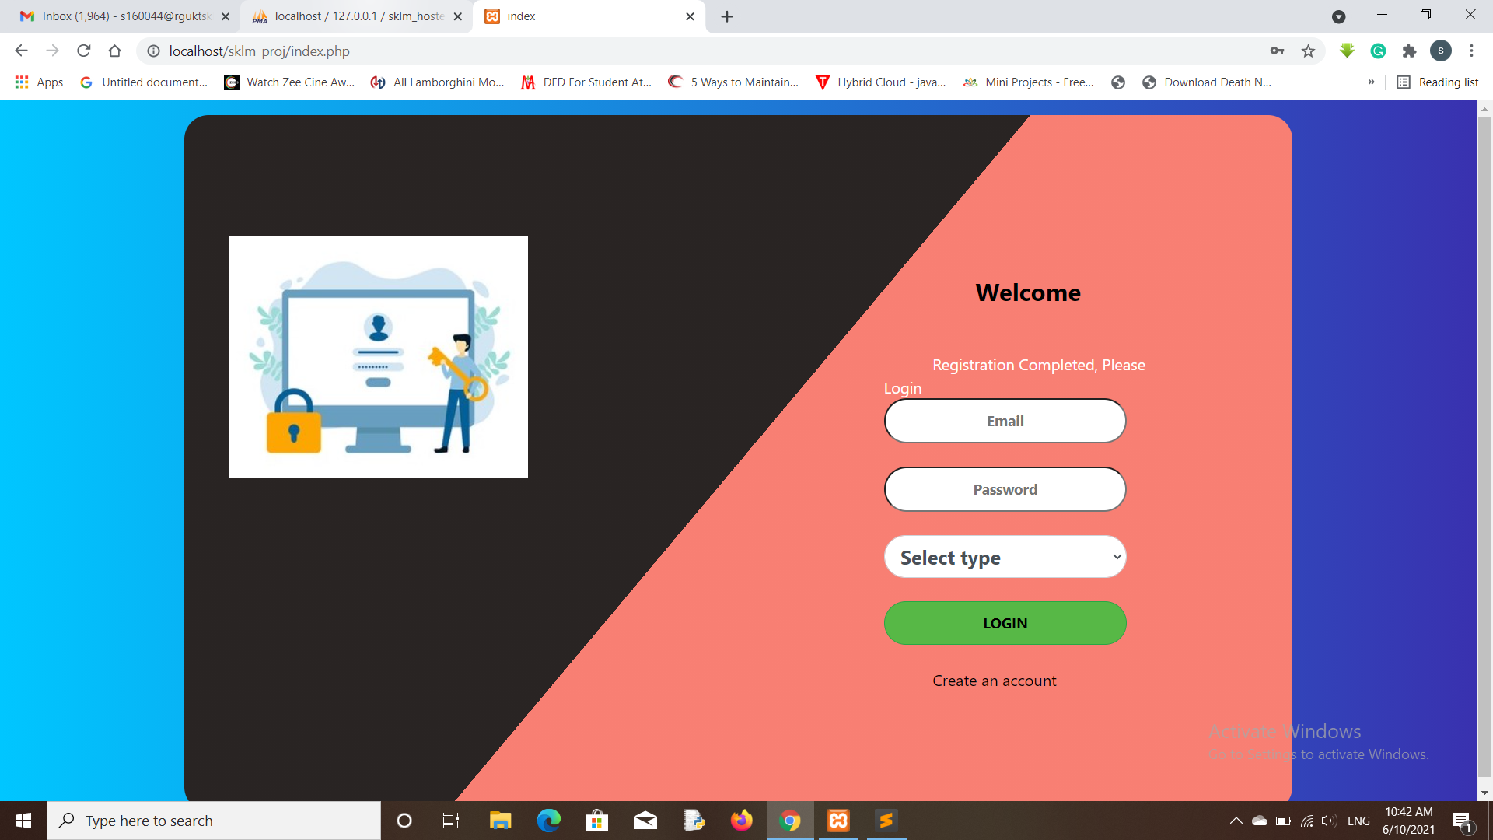

Fig- 7.7 Registration success

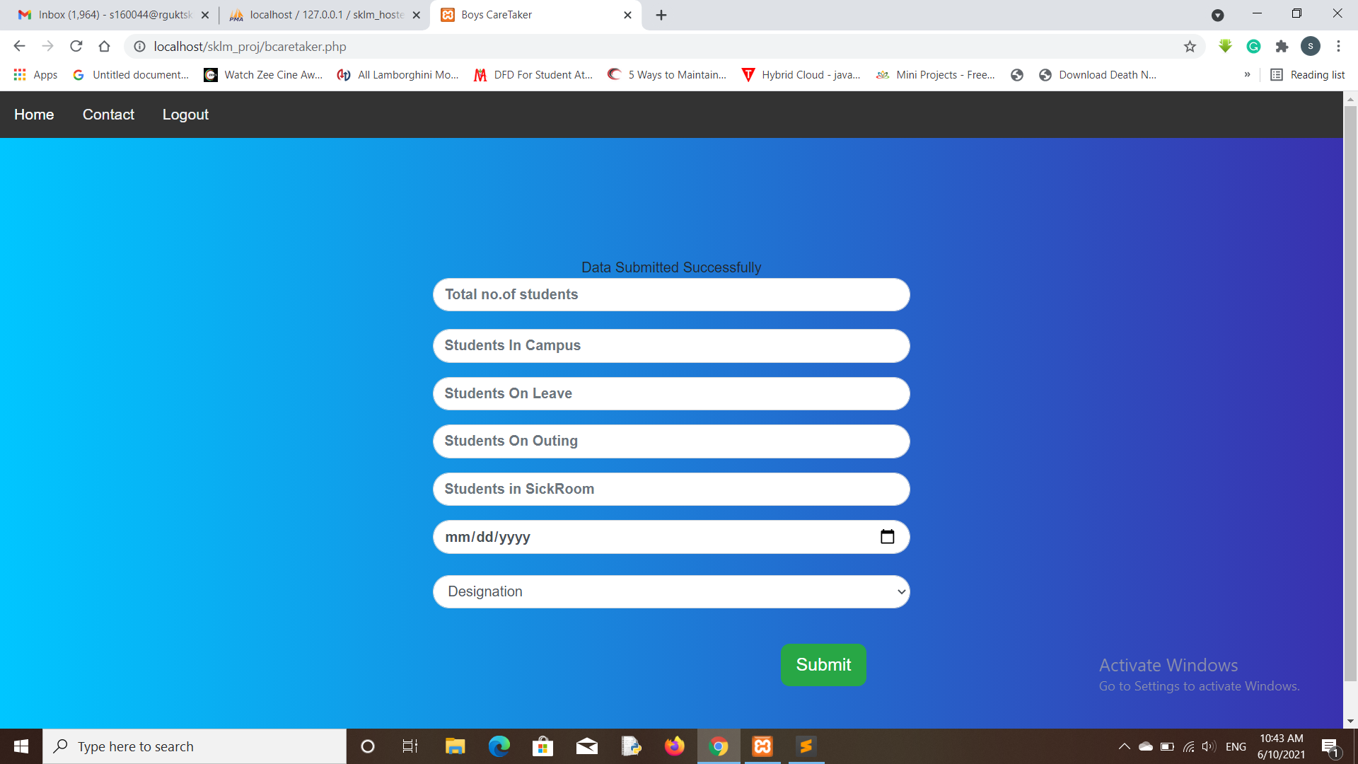

Fig- 7.8 Data Submission Success

**7. TESTING AND VALIDATION**

**7.1 Introduction**

Software testing is an investigation conducted to provide stakeholders with information about the quality of the product or service under test. Software testing also provides an objective, independent view of the software to allow the business to appreciate and understand the risks at implementation of the software. Test techniques include, but are not limited to, the process of executing a program or application with the intent of finding software bugs. Software testing can also be stated as the process of validating and verifying that a software program/application/product meets the business and technical requirements that guided its design and development, Works as expected and can be implemented with the same characteristics. Software testing, depending on the testing method employed, can be implemented at any time in the development process. However, most of the test effort occurs after the requirements have been defined and the coding process has been completed. As such, the methodology of the test is governed by the software development methodology adopted.

Different software development models will focus the test effort at different points in the development process. Newer development models, such as Agile, often employ test driven development and place an increased portion of the testing in the hands of the developer, before it reaches a formal team of testers. In a more traditional model, most of the test execution occurs after the requirements have been defined and the coding process has been completed. Testing can never completely identify all the defects within software. Instead, it furnishes a criticism or comparison that compares the state and behaviour of the product against Oracle's principles or mechanisms by which someone might recognize a problem. These oracles may include (but are not limited to) specifications, contracts, comparable products, past versions of the same product, inferences about intended or expected purpose, user or customer expectations, relevant standards, applicable laws, or other criteria.

**7.2 Types of Testing**

**7.2.1 Unit Testing**

Unit Testing is done on individual modules as they are completed and become executable. It is confined only to the designer's requirements.

**7.2.2 Integration Testing**

Integration testing ensures that software and subsystems work together as a whole. It tests the interface of all the modules to make sure that the modules behave properly when integrated together.

**7.3 Validation**

The system has been tested and implemented successfully and thus ensured that all the requirements as listed in the software requirements specification are completely fulfilled. In case of erroneous input corresponding error messages are displayed.

Table 1: Validation Reports

|  |  |  |  |  |
| --- | --- | --- | --- | --- |
| **Test No.** | **Test Case** | **Expected Output** | **Actual Output** | **Result** |
| **1** | Registration | Data Stored In Table | Data Stored In Table | Passed |
| **2** | Login Credentials | Data Stored In Table | Data Stored In Table | Passed |
| **3** | Caretaker entering details | Data stored in the respective tables | Data stored in the respective tables | Passed |
| **4** | Warden & Chief-warden getting details | Data retrieved from the tables | Data retrieved from the tables | Passed |

**8. Conclusion**

Providing an efficient web application for entry and viewing the details from the

database(storage) and securing with algorithms.This system will help improve productivity

and reliability of the hostel attendance and management process in a more efficient

manners.

**Appendix**

The proposed web application provides the ability to store the details of the students in the campus on the basis of the mails provided by the caretakers and the wardens & chief-wardens are able to see the details entered by the caretaker on a particular date.

**Source Code**

**Registration Page**

<?php

session_start();

require_once 'connection.php';

if (isset($_POST['submit'])){

$firstname = ucfirst($_POST['fn']);

$lastname = $_POST['ln'];

$password = $_POST['pwd'];

$cpassword = $_POST['cpwd'];

$gender = $_POST['gender'];

$des = $_POST['selection'];

$hostel = $_POST['hostel'];

$email = $_POST['email'];

$mobile = $_POST['number'];

$securityQues = $_POST['security'];

$securityAns = $_POST['answer'];

$firstname = mysqli_real_escape_string($db,$firstname);

$lastname = mysqli_real_escape_string($db,$lastname);

$password = mysqli_real_escape_string($db,$password);

$cpassword = mysqli_real_escape_string($db,$cpassword);

$gender = mysqli_real_escape_string($db,$gender);

$des = mysqli_real_escape_string($db,$des);

$hostel = mysqli_real_escape_string($db,$hostel);

$email = mysqli_real_escape_string($db,$email);

$mobile = mysqli_real_escape_string($db,$mobile);

$securityQues = mysqli_real_escape_string($db,$securityQues);

$securityAns = mysqli_real_escape_string($db,$securityAns);

if($password==$cpassword){

$password=md5($password);

if(!preg_match('/^[a-zA-Z\s]+$/', $firstname))

{

$_SESSION['error']="firstname should be only letters and spaces";

}

else{

if(!preg_match('/^[a-zA-Z\s]+$/', $lastname))

{

$_SESSION['error']="Lastname should be only letters and space";

}

else

{

$sql = mysqli_query($db,"SELECT * from users where Email='$email'");

$row = mysqli_fetch_array($sql);

if ($row){

$_SESSION['error']="Already Registered, Please Login";

header("location:index.php");

}else{

$sql = "INSERT INTO users(Email,FirstName,LastName,Gender,Mobile,Hostel,designation,PassWord, SecQuestion, SecAnswer) values

('$email','$firstname','$lastname','$gender','$mobile','$hostel','$des','$password','$securityQues','$securityAns')";

if(mysqli_query($db,$sql)){

$_SESSION['error']="Registration Completed, Please Login";

header("location:index.php");

}

else{

$_SESSION['error']="Error found";

header("location:registration.php");

}

}

}

}

}

else{

$_SESSION['error']="Passwords doesn't match";

header("location:registration.php");

}

}

?>

<!DOCTYPE html>

<html lang="en">

<head>

<title>Registration</title>

<meta charset="utf-8">

<meta name="viewport" content="width=device-width, initial-scale=1">

<link rel="stylesheet" href="bootstrap/css/bootstrap.min.css">

<link rel="stylesheet" type="text/css" href="register.css">

<script type="text/javascript" language="javascript">

function check(input)

{

if(input.value !=document.getElementById('password').value)

{

input.setCustomValidity("Password must match");

}

else

{

input.setCustomValidity('');

}

}

function email()

{

var email=document.f1.email.value;

var reg3=/[A-z0-9]+@[A-z]{5,7}.[A-z]{2,3}/;

var check5=email.match(reg3);

if(check5==null)

{

alert("Invalid e-mail");

return false;

}

}

function firstname()

{

var fname=document.f1.fn.value;

var reg1=/[A-z\s]{3,}/;

var check1=fname.match(reg1);

if(check1!=fname)

{

return false;

}

}

function lastname()

{

var lname=document.f1.ln.value;

var reg2=/[A-z\W]{6,15}/

var check2=lname.match(reg2);

if(check2!=lname)

{

return false;

}

}

</script>

</head>

<body style="background: linear-gradient(-135deg,#4158d0,#c850c0)">

<div class="container register">

<div class="row">

<div class="col-md-3 register-left">

<h3>Welcome</h3>

<a href="index.php"><button >Login</button></a><br/>

</div>

<div class="col-md-9 register-right">

<p style="text-align: center;font-weight: bold;"> <?php if(isset($_SESSION['error'])){echo "<br><span>".$_SESSION['error']."</span>";} ?> </p>

<div class="row register-form">

<div class="col-md-6">

<form action="registration.php" method="post" name="f1">

<div class="form-group">

<input type="text" class="form-control" placeholder="First Name *" value="" name="fn" required oninput="firstname(this)" />

</div>

<div class="form-group">

<input type="text" class="form-control" placeholder="Last Name *" value="" name="ln" required oninput="lastname(this)" />

</div>

<div class="form-group">

<input type="password" class="form-control" placeholder="Password *" value="" name="pwd" id="password" required />

</div>

<div class="form-group">

<input type="password" class="form-control" placeholder="Confirm Password *" value="" name="cpwd" id="confirm" required oninput="check(this)" />

</div>

<div class="form-group">

<div class="maxl">

<label class="radio inline">

<input type="radio" name="gender" value="male">

<span style="font-weight: bold;"> Male </span>

</label>

<label class="radio inline">

<input type="radio" name="gender" value="female">

<span style="font-weight: bold;">Female </span>

</label>

</div>

</div>

<div class="form-group">

<select class="form-control" name="selection" required>

<option class="hidden" selected disabled>Select type</option>

<option name="caretaker" value="caretaker">Care Taker</option>

<option name="warden" value="warden">Warden</option>

<option name="chiefwarden" value="chiefwarden">Chief-Warden</option>

</select>

</div>

</div>

<div class="col-md-6">

<div class="form-group">

<select class="form-control" name="hostel" required>

<option class="hidden" selected disabled>Hostel</option>

<option name="i2" value="i2">I2</option>

<option name="i3" value="i3">I3</option>

</select>

</div>

<div class="form-group">

<input type="email" class="form-control" placeholder="Your Email *" value="" name="email" required oninput="email(this)" />

</div>

<div class="form-group">

<input type="text" class="form-control" placeholder="Phone Number" value="" name="number" required />

</div>

<div class="form-group">

<select class="form-control" name="security" required>

<option class="hidden" selected disabled>Please select your Sequrity Question</option>

<option name="What is your Birthdate" value="What is your Birthdate">What is your Birthdate?</option>

<option name="What is Your Phone Number" value="What is Your Phone Number">What is Your Phone Number</option>

<option name="What is your Pet Name?" value="What is your Pet Name?">What is your Pet Name?</option>

</select>

</div>

<div class="form-group">

<input type="text" class="form-control" placeholder="Enter Your Answer " value="" name="answer" required />

</div>

<button class="btn btnRegister btn-success" name="submit">Register</button>

</form>

</div>

</div>

</div>

</div>

<script src="bootstrap/jquery/3.5.1/jquery.min.js"></script>

<script src="bootstrap/js/bootstrap.min.js"></script>

</body>

</html>

**Registration CSS**

.register-left{

text-align: center;

color: #fff;

margin-top: 4%;

}

.register{

background: -webkit-linear-gradient(left, #3931af, #00c6ff);

margin-top: 3%;

padding: 3%;

border-radius: 25px;

}

.register-left button{

border: none;

border-radius: 1.5rem;

padding: 2%;

width: 60%;

background: #f8f9fa;

font-weight: bold;

color: #383d41;

margin-top: 30%;

margin-bottom: 3%;

cursor: pointer;

}

.register-right{

background: #f8f9fa;

border-top-left-radius: 10% 50%;

border-bottom-left-radius: 10% 50%;

}

.register .register-form{

padding: 10%;

border-top-left-radius: 10% 50%;

border-bottom-left-radius: 10% 50%;

background-color: transparent;

}

.register .register-right input

{

border-radius: 25px;

font-weight: bold;

}

.register .register-right select

{

border-radius: 25px;

font-weight: bold;

}

.btnRegister{

float: right;

margin-top: 10%;

border: none;

border-radius: 15px;

padding: 2%;

color: #fff;

font-weight: 600;

width: 50%;

cursor: pointer;

}

**Index Page**

<?php

$err="";

session_start();

require_once"connection.php";

if(isset($_POST['login'])){

if (!empty($_POST['email']) && !empty($_POST['password'])) {

$email = $_POST['email'];

$password = md5($_POST['password']);

$des = $_POST['type'];

$email = stripslashes($email);

$password = stripslashes($password);

$email = mysqli_real_escape_string($db,$email);

$password = mysqli_real_escape_string($db,$password);

$sql = mysqli_query($db,"SELECT * from users WHERE Email='$email' AND designation='$des'");

$row = mysqli_fetch_array($sql);

if($row){

if($row['PassWord'] == $password){

$_SESSION['error']="Login Successful";

// header("location:bcaretaker.php");

if($row['designation'] =='chiefwarden' || $row['designation']=='warden'){

header("location:chiefwarden.php");

$_SESSION['login_check_warden'] = $email;

}

else{

if($row['Gender']=='male'){

header("location:bcaretaker.php");

$_SESSION['login_check_bcare'] = $email;

}

else{

header("location:gcaretaker.php");

$_SESSION['login_check_gcare'] = $email;

}

}

}

else{

header("location:index.php");

$_SESSION['error']="Invalid Credentials";

}

}

else{

$_SESSION['error']="Account Not Found";

header("location:index.php");

}

}

}

?>

<!DOCTYPE html>

<html lang="en">

<head>

<title>index</title>

<meta charset="utf-8">

<meta name="viewport" content="width=device-width, initial-scale=1">

<link rel="stylesheet" href="bootstrap/css/bootstrap.min.css">

<link rel="stylesheet" type="text/css" href="Customstyles.css">

</head>

<body style="background: -webkit-linear-gradient(left, #00c6ff, #3931af);">

<div class="container login">

<div class="row">

<div class="col-md-3 login-left">

<img src="images/login_image.jpg" id="zoom" />

</div>

<div class="col-md-9">

<div class="row login-form">

<div class="col-md-6 offset-md-6">

<form method="post" name="f" action="index.php" >

<div class="from-group">

<p>Welcome</p>

<?php

if(isset($_SESSION['error'])){

echo "<br><span>".$_SESSION['error']."</span>";

}

?>

</div>

<div class="from-group">

<input type="text" name="email" placeholder="Email" required>

</div><br>

<div class="from-group">

<input type="password" name="password" placeholder="Password" required>

</div><br>

<div class="from-group">

<select class="form-control" name="type" required id="new">

<option class="hidden" selected disabled>Select type</option>

<option name="caretaker" value="caretaker">Care Taker</option>

<option name="warden" value="warden">Warden</option>

<option name="chiefwarden" value="chiefwarden">Chief-Warden</option>

</select>

</div><br>

<button class="btn btn-success" formaction="index.php" name="login" id="gi"><strong>Login</strong></button>

<br><br>

<span class="account"><a href="registration.php">Create an account</a></span>

</form>

</div>

</div>

</div>

</div>

</div>

<script src="bootstrap/jquery/3.5.1/jquery.min.js"></script>

<script src="bootstrap/js/bootstrap.min.js"></script>

</body>

</html>

**Index CSS**

img{

margin-top: 15%;

margin-bottom: 5%;

}

#zoom {

transition: transform .2s; animation

margin: 0 auto;

}

#zoom:hover {

transform: scale(1.25);

border-radius: 10%;

}

.login-left{

text-align: center;

color: #fff;

margin-top: 4%;

}

.login{

background: linear-gradient(-410deg, #f87f73 50%, #292423 50%);

margin-top: 1%;

padding: 3%;

border-radius: 25px;

border-style: none;

}

.login-form{

padding: 10%;

margin-top: 5%;

}

.login .login-form p

{

font-weight: bold;

color: black;

font-size: 25px;

text-align: center;

margin-bottom: 20px;

}

.login .login-form input

{

border-radius: 25px;

font-size: 15px;

padding: 10px;

width: 250px;

background: #e6e6e6;

color: #666;

text-align: center;

background: white;

font-weight: bold;

}

.login .login-form select

{

border-radius: 25px;

font-size: 15px;

width: 250px;

font-weight: bold;

font-size: 20px;

}

.login .login-form button

{

width: 250px;

padding: 10px;

border-radius: 25px;

background: #57B846;

display: inline-block;

text-transform: uppercase;

justify-content: center;

font-size: 15px;

color: #000;

}

.login .login-form span

{

color: white;

padding: 50px;

}

.login .login-form a

{

color: black;

text-decoration: none;

}

**Caretaker**

<?php

session_start();

if(!isset($_SESSION['login_check_bcare'])){

header("location:index.php");

}

if(isset($_POST['submit'])){

require_once 'connection.php';

$total = $_POST['Total_students'];

$incampus = $_POST['students_in_campus'];

$onleave = $_POST['students_on_leave'];

$onouting = $_POST['students_on_outing'];

$insick = $_POST['students_in_sickroom'];

$dateofday = strval($_POST['dateofday']);

$desig = $_POST['desig'];

$total = mysqli_real_escape_string($db,$total);

$incampus = mysqli_real_escape_string($db,$incampus);

$onleave = mysqli_real_escape_string($db,$onleave);

$onouting = mysqli_real_escape_string($db,$onouting);

$insick = mysqli_real_escape_string($db,$insick);

$dateofday = mysqli_real_escape_string($db,$dateofday);

$desig = mysqli_real_escape_string($db,$desig);

$sql = "INSERT INTO student_details(total,incampus,onleave,onouting,insick,dateofday,designation)values

('$total','$incampus','$onleave','$onouting','$insick','$dateofday','$desig')";

if(mysqli_query($db,$sql)){

$_SESSION['error']="Data Submitted Successfully";

header("location:bcaretaker.php");

}

else{

$_SESSION['error']="Error found";

header("location:bcaretaker.php");

}

}

?>

<!DOCTYPE html>

<html>

<head>

<title>Boys CareTaker</title>

<meta charset="utf-8">

<meta name="viewport" content="width=device-width, initial-scale=1">

<link rel="stylesheet" href="bootstrap/css/bootstrap.min.css">

<meta http-equiv="X-UA-Compatible" content="IE-edge">

<script src="bootstrap/jquery/3.5.1/jquery.min.js"></script>

<script src="bootstrap/js/bootstrap.min.js"></script>

<link rel="stylesheet" href="https://cdnjs.cloudflare.com/ajax/libs/font-awesome/4.7.0/css/font-awesome.min.css">

<style type="text/css">

.background

{

/*background: -webkit-linear-gradient(left, #00c6ff, #3931af);*/

height: 650px;

margin-top: 10px;

border-radius: 20px;

text-align: center;

}

.form

{

margin-top: 50px;

}

.left

{

height: 650px;

text-align: right;

padding-top: 50px;

}

.right

{

height: 650px;

padding-top: 50px;

margin-top: 50px;

}

.row .left p

{

margin-top: 20px;

padding-bottom: 8px;

font-weight: bold;

}

.row .right input

{

border-radius: 20px;

font-weight: bold;

}

.row .right button

{

border-radius: 10px;

margin-right: 50px;

}

.row .right select

{

border-radius: 20px;

}

body {margin:0;font-family:Arial}

.topnav {

overflow: hidden;

background-color: #333;

}

.topnav a {

float: left;

display: block;

color: #f2f2f2;

text-align: center;

padding: 14px 16px;

text-decoration: none;

font-size: 17px;

}

.active {

background-color: #04AA6D;

color: white;

}

.topnav .icon {

display: none;

}

.dropdown {

float: left;

overflow: hidden;

}

.dropdown .dropbtn {

font-size: 17px;

border: none;

outline: none;

color: white;

padding: 14px 16px;

background-color: inherit;

font-family: inherit;

margin: 0;

}

.dropdown-content {

display: none;

position: absolute;

background-color: #f9f9f9;

min-width: 160px;

box-shadow: 0px 8px 16px 0px rgba(0,0,0,0.2);

z-index: 1;

}

.dropdown-content a {

float: none;

color: black;

padding: 12px 16px;

text-decoration: none;

display: block;

text-align: left;

}

.topnav a:hover, .dropdown:hover .dropbtn {

background-color: #555;

color: white;

}

.dropdown-content a:hover {

background-color: #ddd;

color: black;

}

.dropdown:hover .dropdown-content {

display: block;

}

@media screen and (max-width: 600px) {

.topnav a:not(:first-child), .dropdown .dropbtn {

display: none;

}

.topnav a.icon {

float: right;

display: block;

}

}

@media screen and (max-width: 600px) {

.topnav.responsive {position: relative;}

.topnav.responsive .icon {

position: absolute;

right: 0;

top: 0;

}

.topnav.responsive a {

float: none;

display: block;

text-align: left;

}

.topnav.responsive .dropdown {float: none;}

.topnav.responsive .dropdown-content {position: relative;}

.topnav.responsive .dropdown .dropbtn {

display: block;

width: 100%;

text-align: left;

}

}

</style>

<script>

function myFunction() {

var x = document.getElementById("myTopnav");

if (x.className === "topnav") {

x.className += " responsive";

}

else {

x.className = "topnav";

}

}

</script>

</head>

<body style="background: -webkit-linear-gradient(left, #00c6ff, #3931af);">

<div class="topnav" id="myTopnav">

<a style="cursor: default;color: white">Home</a>

<a href="about.html">Contact</a>

<a href="logout.php" >Logout</a>

<a href="javascript:void(0);" style="font-size:15px;" class="icon" onclick="myFunction()">&#9776;</a>

</div>

<div class="container background">

<div class="row text">

<div class="col-md-6 offset-md-3 col-sm-6 offset-sm-3 col-xs-6 right">

<?php if(isset($_SESSION['error'])){echo "<br><span>".$_SESSION['error']."</span>";} ?>

<form method="post" action="bcaretaker.php" >

<div class="form-group">

<input class="form-control" type="number" name="Total_students" required placeholder="Total no.of students">

</div>

<div class="form-group">

<input class="form-control" type="number" name="students_in_campus" style="margin-top: 20px;" required placeholder="Students In Campus">

</div>

<div class="form-group">

<input class="form-control" type="number" name="students_on_leave" required placeholder="Students On Leave">

</div>

<div class="form-group">

<input class="form-control" type="number" name="students_on_outing" required placeholder="Students On Outing">

</div>

<div class="form-group">

<input class="form-control" type="number" name="students_in_sickroom" required placeholder="Students in SickRoom">

</div>

<input class="form-control" type="date" name="dateofday" value="" required><br>

<div class="form-group">

<select class="form-control" name="desig" required>

<option class="hidden" selected disabled>Designation</option>

<option name="Nagaraju" value="Nagaraju">P.V.Nagaraju</option>

<option name="Koteswara Rao" value="Koteswara Rao">CH.Koteswara Rao</option>

<option name="Srinu Naik" value="Srinu Naik">M.Srinu Naik</option>

<option name="Ratna Kishore" value="Ratna Kishore">G.Ratna Kishore</option>

</select>

</div><br>

<button class="btn btn-success btn-lg float-right" name="submit">Submit</button>

</form>

</div>

</div>

</div>

</body>

</html>

**Warden & Chief-Warden**

<?php

session_start();

error_reporting(0);

require_once 'connection.php';

if(!isset($_SESSION['login_check_warden'])){

header("location:index.php");

}

if(isset($_POST['submit'])){

$dateofday = $_POST['dateofday'];

$dateofday = mysqli_real_escape_string($db,$dateofday);

}

?>

<!DOCTYPE html>

<!DOCTYPE html>

<html>

<head>

<title>Chief Warden</title>

<meta charset="utf-8">

<meta name="viewport" content="width=device-width, initial-scale=1">

<link rel="stylesheet" href="bootstrap/css/bootstrap.min.css">

<script src="bootstrap/jquery/3.5.1/jquery.min.js"></script>

<script src="bootstrap/js/bootstrap.min.js"></script>

<link rel="stylesheet" href="https://cdnjs.cloudflare.com/ajax/libs/font-awesome/4.7.0/css/font-awesome.min.css">

<style type="text/css">

.body

{

height: 650px;

margin-top: 20px;

text-align: center;

/*background: -webkit-linear-gradient(left, #00c6ff, #3931af);*/

border-radius: 50px;

}

.date

{

border-radius: 10px;

margin-top: 100px;

width: 150px;

}

.submit

{

width: 250px;

padding: 10px;

border-radius: 25px;

justify-content: center;

font-weight: bold;

font-size: 15px;

color: #000;

}

body {margin:0;font-family:Arial}

.topnav {

overflow: hidden;

background-color: #333;

}

.topnav a {

float: left;

display: block;

color: #f2f2f2;

text-align: center;

padding: 14px 16px;

text-decoration: none;

font-size: 17px;

}

.active {

background-color: #04AA6D;

color: white;

}

.topnav .icon {

display: none;

}

.dropdown {

float: left;

overflow: hidden;

}

.dropdown .dropbtn {

font-size: 17px;

border: none;

outline: none;

color: white;

padding: 14px 16px;

background-color: inherit;

font-family: inherit;

margin: 0;

}

.dropdown-content {

display: none;

position: absolute;

background-color: #f9f9f9;

min-width: 160px;

box-shadow: 0px 8px 16px 0px rgba(0,0,0,0.2);

z-index: 1;

}

.dropdown-content a {

float: none;

color: black;

padding: 12px 16px;

text-decoration: none;

display: block;

text-align: left;

}

.topnav a:hover, .dropdown:hover .dropbtn {

background-color: #555;

color: white;

}

.dropdown-content a:hover {

background-color: #ddd;

color: black;

}

.dropdown:hover .dropdown-content {

display: block;

}

@media screen and (max-width: 600px) {

.topnav a:not(:first-child), .dropdown .dropbtn {

display: none;

}

.topnav a.icon {

float: right;

display: block;

}

}

@media screen and (max-width: 600px) {

.topnav.responsive {position: relative;}

.topnav.responsive .icon {

position: absolute;

right: 0;

top: 0;

}

.topnav.responsive a {

float: none;

display: block;

text-align: left;

}

.topnav.responsive .dropdown {float: none;}

.topnav.responsive .dropdown-content {position: relative;}

.topnav.responsive .dropdown .dropbtn {

display: block;

width: 100%;

text-align: left;

}

}

table,th,td{

border: 1px solid white;

}

</style>

<script>

function myFunction() {

var x = document.getElementById("myTopnav");

if (x.className === "topnav") {

x.className += " responsive";

}

else {

x.className = "topnav";

}

}

</script>

</head>

<body style="background: -webkit-linear-gradient(left, #3931af,#00c6ff);">

<div class="topnav" id="myTopnav">

<a style="cursor: default;color: white">Home</a>

<a href="about.html">Contact</a>

<a href="logout.php">Logout</a>

<a href="javascript:void(0);" style="font-size:15px;" class="icon" onclick="myFunction()">&#9776;</a>

</div>

<div class="container">

<div class="row body">

<div class="col-md-12">

<form method="post" action="chiefwarden.php">

<div class="form-group">

<input type="date" name="dateofday" class="date">

</div>

<div class="form-group">

<input type="submit" name="submit" class="submit" target="_self">

</div>

</form>

<div>

<table style="position: relative; margin-left: 250px;">

<tr>

<th>S.NO</th>

<th>Total Students</th>

<th>InCampus</th>

<th>Outing</th>

<th>Onleave</th>

<th>InSick</th>

<th>Date</th>

<th>Caretaker</th>

</tr>

<?php

$sql ="SELECT * FROM student_details WHERE dateofday='$dateofday'";

$sql = mysqli_query($db,$sql);

if(mysqli_num_rows($sql)>0){

$c=1;

while($row = mysqli_fetch_array($sql)){

echo'<tr><td style="padding-left:50px">'.$c++.'</td><td>'.$row['total'].'</td><td>'.$row['incampus'].'</td><td>'.$row['onleave'].'</td><td>'.$row['onouting'].'</td><td>'.$row['insick'].'</td><td>'.$row['dateofday'].'</td><td>'.$row['designation'].'</td></tr>';

}

$sql ="SELECT * FROM gstudent_details WHERE dateofday='$dateofday'";

$sql = mysqli_query($db,$sql);

if(mysqli_num_rows($sql)>0){

$c=1;

while($row = mysqli_fetch_array($sql)){

echo'<tr><td style="padding-left:50px">'.$c++.'</td><td>'.$row['total'].'</td><td>'.$row['incampus'].'</td><td>'.$row['onleave'].'</td><td>' .$row['onouting'].'</td><td>'.$row['insick'].'</td><td>'.$row['dateofday'].'</td><td>'.$row['designation'].'</td></tr>';

}

}

}

else{

echo '<tr><td colspan=7>No Data Found on '.$dateofday.'</td></tr>';

}

?>

</table>

</div>

</div>

</div>

</div>

</div>

</body>

</html>